Course:

Database Management Systems (DBMS)

Assesment 4: LOOPS

Done by: Prithak Gajurel

Registration Number: 20BCE2921

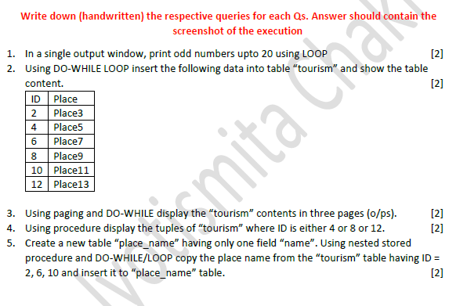

Initial creation of table:

Code:

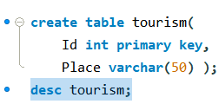

Output:

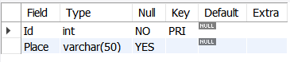



CODE:

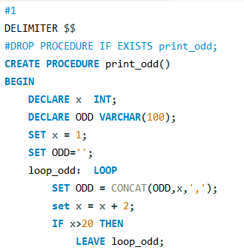

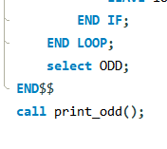

HANDWRITTEN:

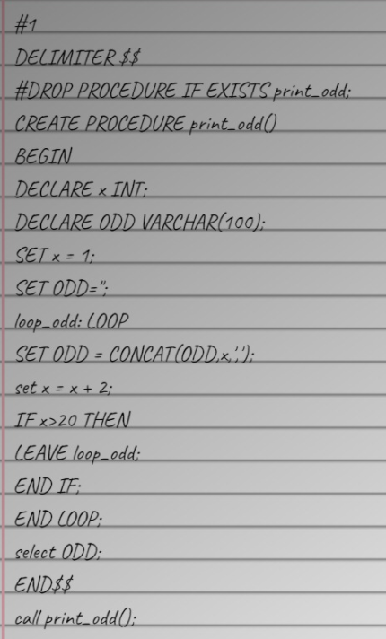

OUTPUT:

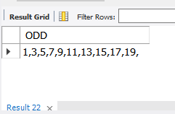

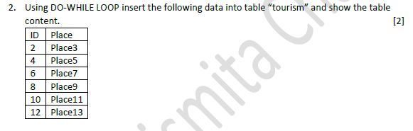

CODE:

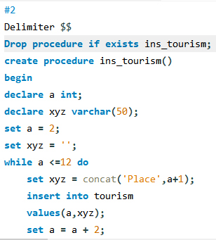

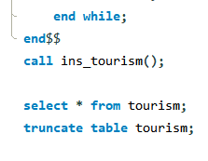

HANDWRITTEN CODE:

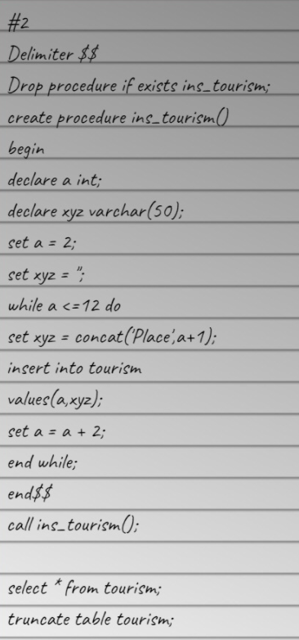

OUTPUT:

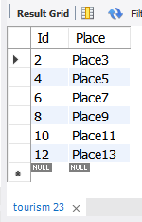



CODE:

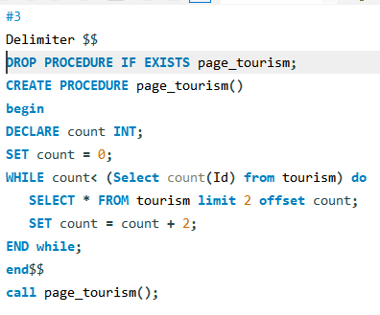

HANDWRITTEN CODE:

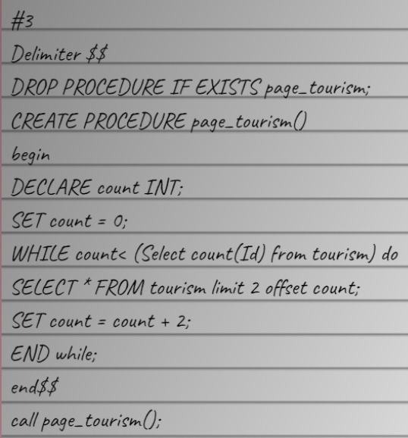

OUTPUTS:

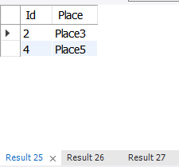

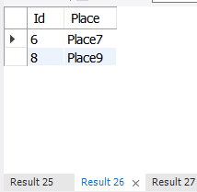

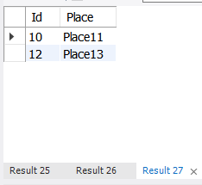



CODE:

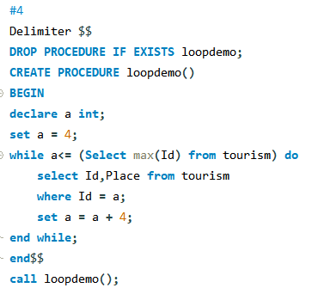

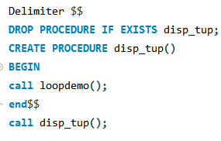

HANDWRITTEN CODE:

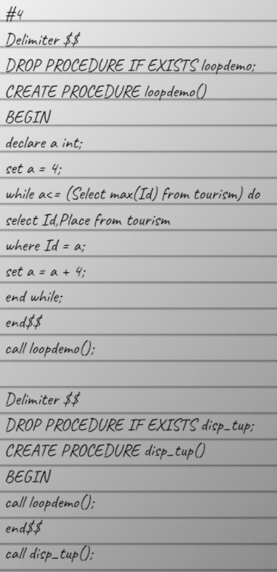

OUTPUT:

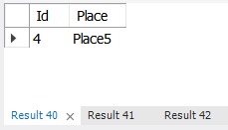

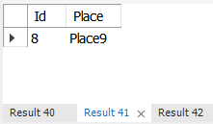

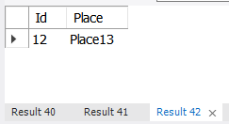

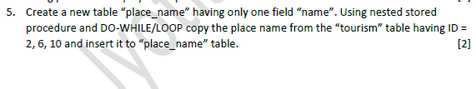

CODE:

#5  
create table place_name (Name varchar (100));  
Delimiter $$  
DROP PROCEDURE IF EXISTS np;  
CREATE PROCEDURE np()  
BEGIN  
insert into place_name values(@contname);  
end$$  
Delimiter $$  
DROP PROCEDURE IF EXISTS While_Loop;  
CREATE PROCEDURE While_Loop()  
BEGIN  
DECLARE Counter, MaxId INT;  
DECLARE ContName VARCHAR(100);  
set counter = (SElect min(Id) from tourism);  
set maxID = (SElect max(Id) from tourism);  
set @contname='';  
  
while (Counter-1 <= MaxId) do  
SET @ContName = (select Place FROM tourism WHERE Id = counter );  
call np();  
SET Counter = Counter + 4;  
END while;  
end$$  
call While_Loop();  
select * from place_name;  
drop table place_name;

Handwritten code:

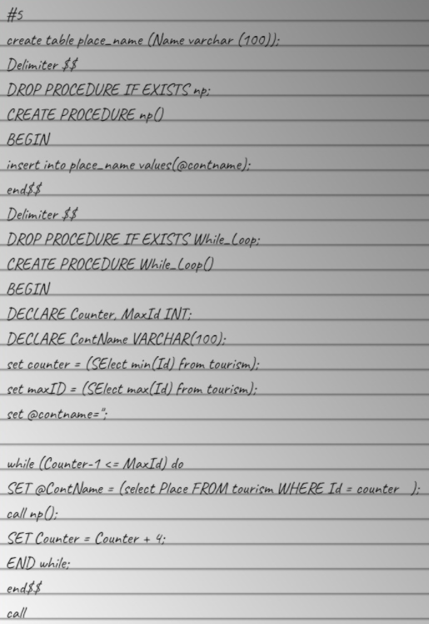

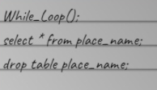

OUTPUT:

